**Network PCA Form**

**PCA Request Details:**

***Requestor Name:*** Adam Bartlett

***Requestor Job Title:*** RME SME, Robotics

***Requestor Team:*** Central SME Robotics, GRT

***Triggering Event WO#:*** N/A

***Triggering Event TT Link (If Applicable):*** N/A

***Brief Description of Root Cause for Triggering Event/Why PCA being requested:***

The JR Automation End of Arm Tool for RWC4 requires a maintained overall dimension for reliable operation. A break-in gap between the side clamps and totes develops over time and requires adjustment. Tie rod adjustments will return the overall dimension to OEM specification for maximum reliability. Impacted sites will need to adjust the tie rods to the OEM specification to avoid totes shifting during robotic motion. Shifting totes will affect tote detection and cause the robot to fault.

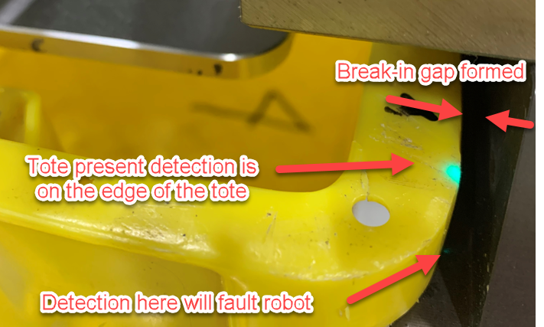

**Impacted Equipment/Sites:**

***Equipment Model/Models Impacted:*** RWC4 Robotic Tote Palletizer End of Arm Tool

***EAM Profile:*** JRWCV5

***Sites Impacted:***

|  |  |  |  |  |  |  |  |  |  |  |  |  |  |  |  |
| --- | --- | --- | --- | --- | --- | --- | --- | --- | --- | --- | --- | --- | --- | --- | --- |
| ABE8 | BNA3 | DAL3 | FTW6 | LAS1 | MEM4 | OXR1 | SLC1 | ABQ1 | BOI2 | DCA1 | FWA4 | LAS2 | MIA1 | PCW1 | SMF3 |
| ACY1 | BWI2 | DEN3 | GEG1 | LAS7 | MKE1 | PDX9 | STL8 | AFW1 | CAE1 | DEN4 | GRR1 | LAX9 | MKE2 | PHL7 | TEB9 |
| AGS1 | CHA1 | DET3 | GYR1 | LEX1 | MQJ1 | PSP1 | TPA1 | AKC1 | CLE2 | DFW7 | GYR2 | LEX2 | MQY1 | RDG1 | TPA4 |
| ATL2 | CLE3 | DSM5 | GYR3 | LGB3 | MTN1 | RDU1 | TUL2 | AUS2 | CLT2 | DTW1 | HOU6 | LGB7 | OAK4 | RIC2 | TUS2 |
| AUS3 | CLT4 | ELP1 | IGQ1 | LGB8 | OKC1 | RNO1 | VGT1 | BDL3 | CMH1 | EWR4 | IND1 | LIT1 | ONT2 | SAN3 | VGT2 |
| BFL1 | CMH4 | EWR9 | IND9 | MCO1 | ONT6 | SAT2 | YHM1 | BFL2 | CSG1 | FAT1 | JAX7 | MDW2 | ORD5 | SBD1 | YOW3 |
| BHM1 | DAL2 | FTW1 | JFK8 | MEM1 | ORF2 | SCK4 |  |  |  |  |  |  |  |  |  |

**General Information:**

***PCA Work Order Description:*** RWC4 EoAT Side Clamp Adjustments

***Is LOTO needed:*** Yes

***# of Techs required to perform task:***2 MHE techs

***Estimated Time to complete (in hours):*** 0.75 hours

***Requested PCA Due Date:*** 7/05/2022

***Enter General Task instructions for WO:***

* Technician will be required to fill safety forms, wear proper PPE and follow all required safety protocols before starting the job.
* Follow the [job plan](https://amazon.awsapps.com/workdocs/index.html#/document/fc61cc9758b402a62ea3a7aff10ee1e17b0e4d28ee62593dd064f5bc58d77ce6) and make an accurate measurement of the side clamp overall dimensions.
* If adjustment is necessary, follow the [job plan](https://amazon.awsapps.com/workdocs/index.html#/document/fc61cc9758b402a62ea3a7aff10ee1e17b0e4d28ee62593dd064f5bc58d77ce6).
* Make the necessary adjustments to the tie rods specified in the [job plan](https://amazon.awsapps.com/workdocs/index.html#/document/fc61cc9758b402a62ea3a7aff10ee1e17b0e4d28ee62593dd064f5bc58d77ce6).
* Return the cell to operation and monitor performance
* Verify dimensions after 24 hours of machine usage.

***Is there a network MCM/CR for this PCA request:*** No

***Is a PO required for this PCA (Yes or No?):*** No

***Are the sites responsible for submitting PO (Yes or No or N/A?):*** N/A

***If No, provide PO/Tracking information for the impacted sites below:*** N/A

***Additional Information:***

* Job plan: [RWC4 EoAT Side Clamp Adjustment](https://amazon.awsapps.com/workdocs/index.html#/document/fc61cc9758b402a62ea3a7aff10ee1e17b0e4d28ee62593dd064f5bc58d77ce6)
* Specifics on the End of Arm Tool assembly (APN 77793, MPN JR JR0000487232): [RWC4 Mechanical Drawings](https://amazon.awsapps.com/workdocs/index.html#/document/860dca7edb72c1f981da80f31d2df2410fe2142d204bfbdb7829d8c42ac1a406).
* Monitor and escalate any issues to [robotics-sme-team@amazon.com](mailto:robotics-sme-team@amazon.com)